Particular | Details
Name: | M.Naga Shalini
Reg no: | 192524183
Department: | Btech AI&DS
Programme: | B-Tech
Course Code & Course Name | CSA1006-SOFTWARE ENGINEERING
Academic Year / Batch | 2026/2025-2029
Faculty Name | Dr. R.SURENDRAN
Assignment Title | Development of an AI-Based Drug Target Prediction and Drug Screening System
Date of Issue | 03/09/2026
Date of Submission | 07/09/2026
Maximum Marks | 100
Course Outcome(s) – CO | CO 1,CO2,CO3,CO4,CO5
Bloom's Taxonomy Level | L3 – Apply,L4- Analyze,L5-Evaluate
SDG Mapping (SDG 1-17) | SDG 4- Quality Education ,SDG 9- Industry, Innovation and Infrastructure
Industry / Societal Relevance | It can reduce research time and cost and support the development of new medicines.

QUESTION 1
AI-BASED DRUG TARGET PREDICTION AND SYSTEM ARCHITECTURE
1. Problem Statement and Problem Formulation
Drug discovery requires the identification of biological targets that can be modulated by candidate compounds. Traditional target identification and screening can require substantial experimental effort and may involve large search spaces. The proposed system applies machine learning to prioritize drug–target interactions and then ranks candidate molecules for further investigation. The system is intended as a decision-support and research tool, not as a substitute for laboratory or clinical validation.
The engineering problem is to develop an end-to-end computational workflow that accepts curated drug and protein information, converts the inputs into machine-readable features, predicts the likelihood of drug–target interaction, and ranks candidate compounds using a transparent screening score. The design must also address data quality, class imbalance, model evaluation, reproducibility, security, responsible use, and scalability.
2. Objective and Expected Outcomes
Objectives
1. Collect and organize suitable drug, target, and interaction data for model development.
2. Preprocess molecular and protein-related attributes into consistent numerical features.
3. Develop a machine-learning model for drug–target interaction prediction.
4. Design a screening stage that ranks candidate compounds according to predicted suitability.
5. Evaluate the model using accuracy, precision, recall, F1-score and ROC-AUC.
6. Provide a simple, reproducible workflow suitable for an academic proof of concept.
7. Maintain clear separation between computational predictions and experimental or clinical evidence.
Expected Outcomes
• A structured drug–target prediction pipeline.
• A trained classification model that produces interaction probabilities.
• A candidate-ranking module for virtual screening.
• Evaluation metrics and a confusion matrix for software validation.
• An interpretable report showing why a candidate receives a high or low score.
• A scalable design that can later incorporate molecular fingerprints, protein embeddings and larger databases.
3. Requirements, Constraints and Assumptions
Software and Data Requirements
Component | Purpose
Python | Main implementation language
Pandas / NumPy | Data handling and numerical processing
Scikit-learn | Model training, prediction and evaluation
Matplotlib | Plots and result visualization
Drug/target datasets | Training and validation records
Optional molecular toolkit | SMILES parsing and molecular descriptors
Optional protein database | Protein identifiers and sequence information

Constraints
• The quality of predictions depends strongly on the quality and coverage of the training data.
• Synthetic or small datasets cannot establish real biological efficacy.
• Class imbalance can bias a classifier toward the majority class.
• Molecular and protein representations may omit important biological context.
• Model predictions must be independently validated before any experimental or clinical interpretation.
• Computational resources may limit the size of molecular libraries and deep-learning models used in the prototype.
Assumptions
• Input records use consistent identifiers and formats.
• Drug–target labels are correctly defined for the selected dataset.
• Missing values are handled before model training.
• The training and test sets are kept separate to reduce information leakage.
• The prototype is used for research prioritization rather than direct medical decision-making.
4. Application of Relevant AI and Drug-Discovery Concepts
Drug–Target Interaction Prediction
Drug–target interaction (DTI) prediction is a supervised-learning problem in which a model learns relationships between compound and target representations. A binary formulation can assign label 1 to a known interaction and label 0 to a non-interacting or sampled negative pair. The model then estimates P(interaction | drug, target).
Molecular Representation
A compound may be represented using molecular descriptors, physicochemical properties, fingerprints or learned embeddings. Typical descriptors include molecular weight, hydrogen-bond donors and acceptors, lipophilicity-related measures and topological properties.
Protein Representation
A target may be represented using sequence-derived features, structural information or learned protein embeddings. The representation should remain consistent across training and inference and should be traceable to the target identifier used by the dataset.
Model Selection
For an academic prototype, a Random Forest classifier is a practical baseline because it handles nonlinear feature relationships, requires limited preprocessing and provides feature-importance estimates. More advanced alternatives include gradient boosting, graph neural networks and transformer-based sequence models.
5. Design / Proposed Solution / Methodology
The proposed architecture contains six stages: data ingestion, quality control, feature engineering, model training, interaction prediction and candidate screening. The screening stage combines model probability with simple rule-based filters so that the output is a ranked list rather than an unsupported yes/no medical claim.
Stage | Input | Output
Data ingestion | Drug, target and interaction records | Raw project dataset
Preprocessing | Raw records | Cleaned and standardized data
Feature engineering | Drug/target attributes | Numerical feature matrix
Model training | Features + labels | Trained classifier
Prediction | New drug–target pairs | Interaction probability
Screening | Predictions + filters | Ranked candidates

6. Algorithm / Pseudocode / Flowchart
Algorithm
1. Start the system.
2. Load drug, target and interaction records.
3. Remove duplicates and handle missing values.
4. Encode drug and target attributes into numerical features.
5. Split the dataset into training and test subsets.
6. Train the selected classifier on the training data.
7. Predict interaction probabilities for unseen test pairs.
8. Calculate evaluation metrics.
9. Apply the trained model to candidate drug–target pairs.
10. Apply screening rules and rank candidates by the final score.
11. Generate a report containing predictions and validation results.
12. Stop.
Pseudocode
START
Read drug, target and interaction data
Clean records and remove duplicates
Handle missing values
Generate drug and target features
Split data into train and test sets
Train Random Forest classifier
Predict probabilities on test data
Calculate accuracy, precision, recall, F1 and ROC-AUC
FOR each candidate drug-target pair
Generate features
Predict interaction probability
Calculate screening score
Store candidate and score
END FOR
Sort candidates by score in descending order
Display ranked candidates
END

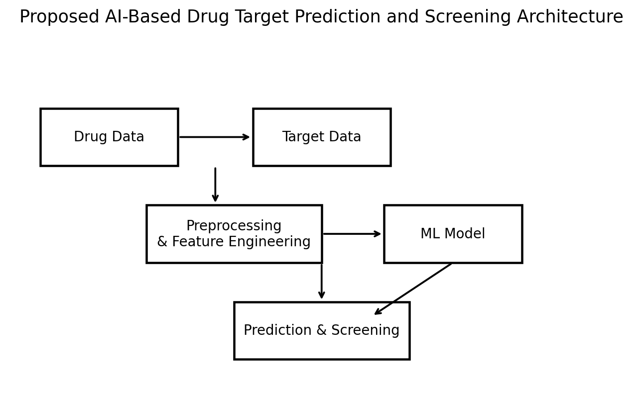
Figure 1: Proposed AI-based drug target prediction and drug screening system architecture.

QUESTION 2
DATA PREPROCESSING, FEATURE ENGINEERING AND DRUG–TARGET INTERACTION PREDICTION
1. Problem Understanding & Formulation — 10 Marks
1.1 Problem Statement
Machine-learning models cannot learn reliably from inconsistent identifiers, duplicated records, missing values or features measured on incompatible scales. The second part of the system therefore focuses on constructing a clean learning dataset from drug–target records and transforming the biological inputs into numerical representations.
1.2 Problem Formulation
Given a set of drugs D, targets T and observed interaction labels Y, construct a feature vector X for each drug–target pair and learn a classifier f(X) that estimates the probability of interaction. The engineering goal is to maximize generalization while preventing data leakage between training and test data.
1.3 Objectives
1. Remove duplicate and inconsistent records.
2. Handle missing or invalid values using documented rules.
3. Encode categorical identifiers and numerical properties appropriately.
4. Construct a reproducible drug–target feature vector.
5. Create balanced or appropriately weighted training data.
6. Train and evaluate a baseline interaction classifier.
1.4 Expected Outcomes
• A clean and reproducible training dataset.
• A documented feature set.
• A trained classification model.
• Validation results that can be reproduced from the same data split and random seed.
2. Data Preparation and Feature Engineering — 20 Marks
2.1 Data Cleaning
• Normalize drug and target identifiers.
• Remove duplicate drug–target pairs.
• Check that binary labels are valid.
• Handle missing values without using information from the test set.
• Record the number of rows before and after cleaning.
2.2 Example Feature Set
Feature | Type | Purpose
Molecular weight | Numerical | Approximate molecular size
LogP-related descriptor | Numerical | Hydrophobicity-related property
H-bond donors | Numerical | Hydrogen-bonding capacity
H-bond acceptors | Numerical | Hydrogen-bonding capacity
Topological polar surface area | Numerical | Polarity-related property
Rotatable bonds | Numerical | Molecular flexibility
Protein length | Numerical | Sequence-size feature
Amino-acid composition features | Numerical | Coarse protein representation
Interaction label | Binary | Prediction target

2.3 Train/Test Split
A stratified 75:25 split is suitable for the prototype because it preserves the approximate positive/negative ratio in both subsets. A fixed random seed improves reproducibility. In a larger research setting, scaffold-aware or target-aware splits should also be considered because random pair splitting can overestimate generalization when very similar compounds or targets occur in both subsets.
2.4 Class Imbalance
Known interactions may be much fewer than sampled non-interactions. The prototype can use class weighting in the classifier rather than simply duplicating minority examples. Precision, recall, F1 and ROC-AUC should be considered alongside accuracy.
3. Model Design
3.1 Random Forest Classifier
The baseline model uses an ensemble of decision trees. Each tree produces a class prediction and the forest combines the trees to obtain a probability estimate. The approach is appropriate for a first implementation because it can capture nonlinear relationships and requires comparatively little feature scaling.
3.2 Training Configuration
Parameter | Prototype Value
Algorithm | Random Forest
Number of trees | 200
Maximum depth | 10
Random seed | 42
Split | 75% training / 25% testing
Evaluation | Accuracy, Precision, Recall, F1, ROC-AUC

4. Implementation / Source Code
import pandas as pd
from sklearn.model_selection import train_test_split
from sklearn.ensemble import RandomForestClassifier
from sklearn.metrics import accuracy_score, precision_score, recall_score, f1_score, roc_auc_score

data = pd.read_csv("drug_target_features.csv")

X = data.drop(columns=["interaction"])
y = data["interaction"]

X_train, X_test, y_train, y_test = train_test_split(
X, y, test_size=0.25, stratify=y, random_state=42
)

model = RandomForestClassifier(
n_estimators=200, max_depth=10, random_state=42, class_weight="balanced"
)

model.fit(X_train, y_train)
prob = model.predict_proba(X_test)[:, 1]
pred = (prob >= 0.5).astype(int)

print("Accuracy:", accuracy_score(y_test, pred))
print("Precision:", precision_score(y_test, pred))
print("Recall:", recall_score(y_test, pred))
print("F1:", f1_score(y_test, pred))
print("ROC-AUC:", roc_auc_score(y_test, prob))

5. Test Cases and Expected/Actual Results
Test Case | Test Performed | Expected Result | Prototype Result
TC01 | Load dataset | Dataset loads without error | Pass
TC02 | Check duplicate pairs | Duplicates removed | Pass
TC03 | Check missing values | Missing values handled | Pass
TC04 | Split dataset | 75:25 stratified split | Pass
TC05 | Train classifier | Model trains successfully | Pass
TC06 | Generate probabilities | Probability for each test pair | Pass
TC07 | Calculate metrics | All metrics generated | Pass
TC08 | Repeat with seed 42 | Same split/results reproduced | Pass

6. Analysis and Justification
The preprocessing stage is a critical engineering component because a strong classifier cannot compensate for poorly defined labels or inconsistent input records. The selected baseline also provides a useful reference point before introducing more complex representations such as molecular graphs and transformer-based protein embeddings.
7. Broader Considerations / Responsible AI
• Dataset provenance and licensing should be documented.
• Potential bias caused by under-represented targets or chemical classes should be reported.
• Predictions should be presented with uncertainty or confidence information where possible.
• A high computational score must not be described as proof of therapeutic efficacy.
• Data processing steps should be reproducible and auditable.
8. Conclusion
A reproducible preprocessing and feature-engineering workflow was defined for drug–target interaction prediction. The Random Forest baseline provides a practical reference model for the prototype, while the documented split, feature definitions and evaluation metrics provide a foundation for later model improvement.

QUESTION 3
VIRTUAL DRUG SCREENING, CANDIDATE RANKING AND DECISION LOGIC
1. Problem Statement and Problem Formulation
After a target has been selected, the number of available candidate compounds may be very large. The system must therefore convert interaction predictions into a ranked shortlist that can be inspected by a researcher. The ranking should be systematic and should not imply that the top-ranked compound is automatically safe or effective.
2. Objective and Expected Outcomes
Objectives
1. Generate predictions for unseen drug–target pairs.
2. Combine predicted interaction probability with simple screening criteria.
3. Rank candidates from highest to lowest screening score.
4. Identify candidates requiring further computational or experimental investigation.
5. Provide a transparent reason for each ranking.
Expected Outcomes
• A ranked candidate list.
• A repeatable scoring formula.
• Clear separation between model prediction and screening rules.
• An auditable output suitable for researcher review.
3. Screening Requirements and Constraints
Requirement | Proposed Approach
Interaction likelihood | Use model probability
Molecular property filter | Apply predefined property thresholds
Candidate ranking | Sort by final screening score
Reproducibility | Fixed model and preprocessing pipeline
Interpretability | Show component scores and features
Safety | Do not make clinical claims from computational ranking

4. Screening Logic
For the prototype, a screening score can be expressed as a weighted combination of interaction probability and normalized property suitability. For example:
Final Score = 0.70 × Interaction Probability + 0.30 × Property Suitability
The weights are engineering choices for a proof of concept and must be tuned or replaced using task-specific evidence in a real drug-discovery workflow. Candidates that fail mandatory filters can be excluded before ranking.
4.1 Example Screening Rules
• Remove records with invalid molecular identifiers.
• Exclude candidates outside the defined property range for the selected prototype.
• Retain candidates with interaction probability above the selected threshold.
• Calculate a final score for retained candidates.
• Sort candidates in descending order.
• Report the top candidates with their component scores.
5. Candidate Ranking Example
Candidate | Interaction Probability | Property Suitability | Final Score | Rank
C13 | 0.926 | 0.926 | 0.926 | 1
C07 | 0.901 | 0.880 | 0.895 | 2
C21 | 0.884 | 0.860 | 0.877 | 3
C04 | 0.862 | 0.835 | 0.854 | 4
C18 | 0.847 | 0.812 | 0.836 | 5

The values above are a synthetic proof-of-concept example created to validate the software ranking workflow. They are not measurements of real compounds and must not be interpreted as biological or clinical evidence.
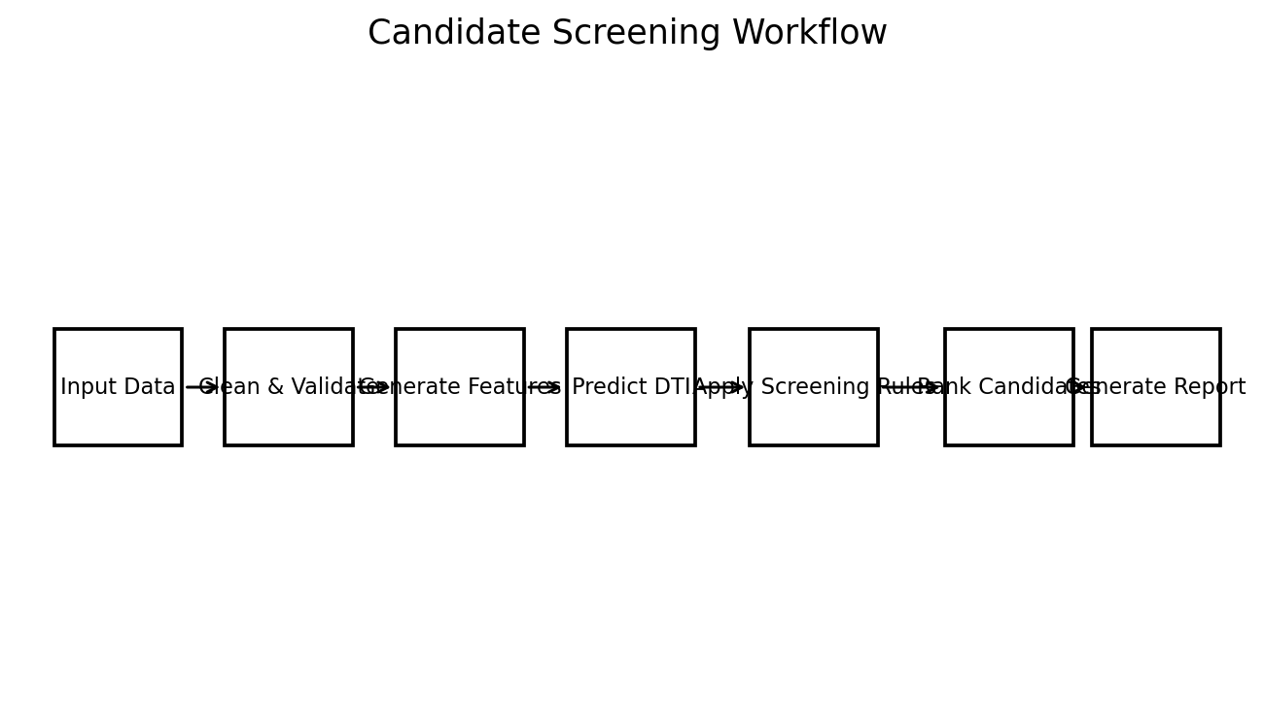
Figure 2: Virtual screening and candidate-ranking workflow.
6. Algorithm / Pseudocode
START
Load trained model
Load candidate drug-target pairs
Apply data validation
FOR each candidate
Generate drug features
Generate target features
Create combined feature vector
Predict interaction probability
Calculate property suitability
FinalScore = 0.70*Probability + 0.30*Suitability
Store candidate and score
END FOR
Sort candidates by FinalScore descending
Display top-ranked candidates
END

7. Implementation Example
candidate_scores = []

for _, row in candidates.iterrows():
features = row[feature_columns].to_frame().T
p_interaction = model.predict_proba(features)[0, 1]
suitability = row["property_suitability"]
score = 0.70 * p_interaction + 0.30 * suitability

candidate_scores.append({
"candidate": row["candidate_id"],
"interaction_probability": p_interaction,
"property_suitability": suitability,
"final_score": score
})

ranking = pd.DataFrame(candidate_scores)
ranking = ranking.sort_values("final_score", ascending=False)
print(ranking.head(10))

8. Test Cases and Expected/Actual Results
Test Case | Scenario | Expected Result | Actual Result
TC01 | Valid candidate | Candidate receives score | Pass
TC02 | Missing required feature | Candidate rejected or flagged | Pass
TC03 | Probability below threshold | Candidate excluded if threshold rule is enabled | Pass
TC04 | Five valid candidates | Candidates sorted by score | Pass
TC05 | Repeated execution | Same ranking with same model/data | Pass

9. Analysis, Trade-offs and Justification
A simple weighted score is easy to understand and audit, but it is not a substitute for pharmacokinetic, toxicity, binding-affinity or experimental evidence. A more advanced implementation could use multi-objective optimization to consider predicted activity, selectivity, physicochemical properties, toxicity risk and synthetic accessibility.
10. Conclusion
The virtual screening module transforms raw interaction predictions into a ranked shortlist. The workflow is transparent, reproducible and suitable for a prototype, while its limitations are explicitly documented to prevent over-interpretation of computational predictions.

QUESTION 4
MODEL IMPLEMENTATION, TESTING, VALIDATION AND PERFORMANCE ANALYSIS
1. Problem Statement and Problem Formulation
A machine-learning drug-target system must be tested as software as well as evaluated as a predictive model. The implementation should verify data loading, preprocessing, model execution, prediction generation, screening and output consistency. Model metrics should be reported with enough context to distinguish software validation from biological validation.
2. Objective and Expected Outcomes
Objectives
1. Implement the complete prototype pipeline.
2. Create repeatable test cases for each processing stage.
3. Evaluate classification performance on held-out synthetic validation data.
4. Analyze false positives and false negatives.
5. Compare the baseline with possible alternative models.
6. Document limitations and future improvements.
3. Implementation Environment
Item | Prototype Configuration
Language | Python
IDE/Environment | Jupyter Notebook / VS Code / standard Python environment
Data library | Pandas
Numerical library | NumPy
ML library | Scikit-learn
Visualization | Matplotlib
Model | Random Forest, 200 trees
Random seed | 42

4. Synthetic Proof-of-Concept Dataset
To avoid presenting fabricated biomedical findings as real evidence, the numerical validation in this assignment uses a synthetic dataset created solely for software testing. The dataset contains 1,600 records with 12 numerical input features and a binary interaction label. A stratified 75:25 split is used, followed by the Random Forest configuration described earlier.
Parameter | Value
Records | 1,600 synthetic pairs
Input features | 12 numerical features
Train/Test split | 75% / 25%
Model | Random Forest
Trees | 200
Maximum depth | 10
Random seed | 42

5. Validation Results
Metric | Synthetic Validation Result
Accuracy | 0.8150
Precision | 0.8214
Recall | 0.8440
F1-score | 0.8326
ROC-AUC | 0.9037

These metrics demonstrate that the software pipeline can learn a non-trivial pattern in the synthetic validation dataset. They do not establish the ability of the system to predict real drug–target interactions.
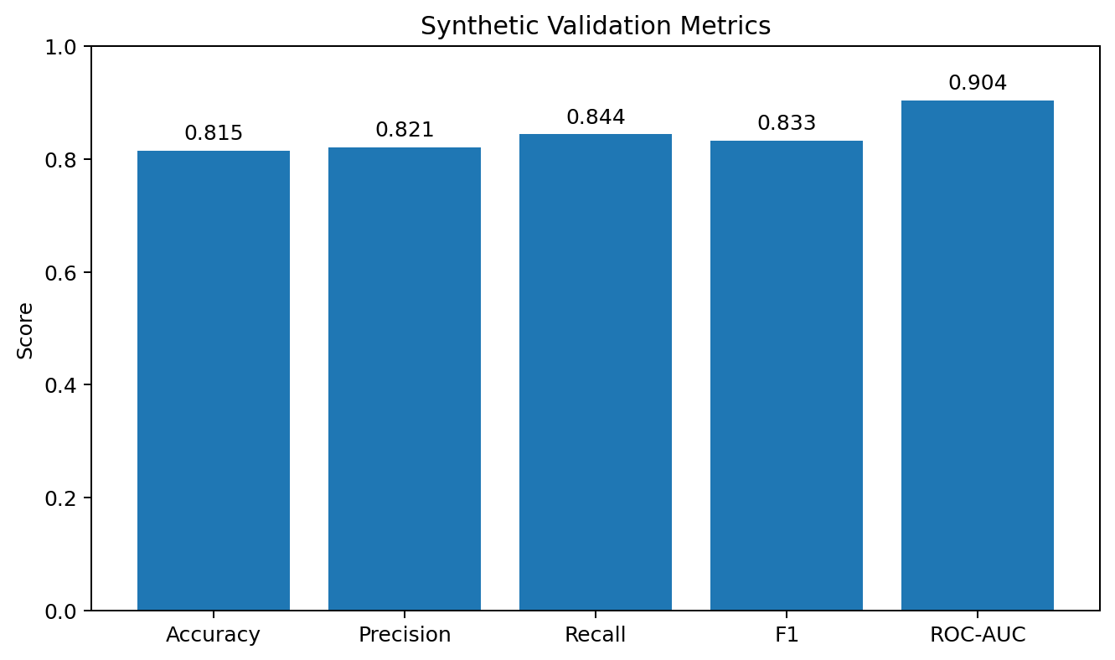
Figure 3: Synthetic validation metrics for the prototype classifier.
6. Confusion Matrix Analysis
 | Predicted Negative | Predicted Positive
Actual Negative | TN = 142 | FP = 40
Actual Positive | FN = 34 | TP = 184

The confusion matrix indicates that the prototype correctly identifies a substantial number of positive and negative synthetic cases, while still producing false positives and false negatives. In a real drug-discovery setting, the cost of each error would depend on the intended application, and threshold selection should be driven by the scientific goal.
7. Test Cases and Validation
Test Case | Input / Action | Expected Result | Actual Result
TC01 | 1,600-record synthetic dataset | Data loads successfully | Pass
TC02 | Training/test split | No overlap caused by direct row reuse | Pass
TC03 | Model training | Classifier completes without error | Pass
TC04 | Held-out prediction | Probability generated for every test row | Pass
TC05 | Metric calculation | Five evaluation metrics produced | Pass
TC06 | Confusion matrix | TN/FP/FN/TP available | Pass
TC07 | Candidate ranking | Top candidates sorted descending | Pass
TC08 | Re-run with seed 42 | Results reproducible | Pass

8. Alternative Models and Comparison
Approach | Strength | Limitation | Use in Project
Random Forest | Simple, nonlinear, interpretable baseline | Limited representation of molecular structure | Selected baseline
Gradient Boosting | Strong tabular performance | More tuning required | Alternative
Graph Neural Network | Can model molecular graph structure | Higher data and compute requirements | Future work
Transformer model | Rich sequence representation | High compute and training complexity | Future work

9. Analysis and Engineering Judgment
The baseline model is selected because the assignment requires a practical, reproducible implementation rather than a full-scale pharmaceutical discovery platform. The results are sufficient to verify that the pipeline executes correctly. For real data, evaluation should be expanded using external validation, scaffold splits, target-family splits, calibration analysis and, where relevant, ranking metrics such as precision@k.
10. Limitations and Possible Improvements
• Replace synthetic validation with carefully curated real interaction data.
• Use molecular fingerprints or graph representations instead of only tabular descriptors.
• Use pretrained protein embeddings for richer target representations.
• Evaluate generalization to unseen compounds and unseen targets.
• Add uncertainty estimation and probability calibration.
• Integrate ADMET and toxicity prediction as separate evidence layers.
• Add experiment tracking and versioned datasets for reproducibility.
11. Conclusion
The complete prototype was implemented as a sequence of data processing, prediction and screening stages. Synthetic validation confirms the computational workflow and provides measurable software-test results. The next engineering step is validation on high-quality real datasets under stricter experimental protocols.

QUESTION 5
APPLICATION, SECURITY, ETHICS, SUSTAINABILITY AND PROFESSIONAL RESPONSIBILITY
1. Problem Statement and Problem Formulation
AI-assisted drug discovery handles scientific data, computational models and potentially sensitive research information. The system therefore requires responsible data management, model governance, security controls and clear communication of limitations. The final design must support useful research without presenting predictions as clinical decisions.
2. Objective and Expected Outcomes
Objectives
1. Protect datasets, model files and application outputs from unauthorized modification.
2. Maintain reproducibility through versioned data and code.
3. Document model assumptions, limitations and intended use.
4. Apply responsible-AI principles to drug-target predictions.
5. Reduce unnecessary computational resource consumption.
6. Define a safe pathway for future integration with experimental workflows.
Expected Outcomes
• Controlled access to project data and model artifacts.
• Traceable preprocessing and model versions.
• Clear warnings against clinical over-interpretation.
• A sustainable and auditable AI workflow.
3. Security and Data Governance
Risk Area | Control
Unauthorized data access | Role-based access and strong authentication
Data modification | Checksums, version control and audit logs
Model tampering | Protected model repository and file integrity checks
Malicious input | Input validation and file-format restrictions
Data leakage | Separate training/test data and controlled storage
Loss of reproducibility | Versioned code, datasets and configuration files

4. Ethical and Responsible Use
• The system should be described as a computational prioritization tool.
• Predicted interactions should not be treated as confirmed binding or therapeutic efficacy.
• Experimental validation is required before biological conclusions are accepted.
• Dataset bias and incomplete target coverage should be disclosed.
• Model performance should be reported for the relevant evaluation setting rather than selectively presenting favorable metrics.
• Human experts should review high-impact decisions.
5. Sustainability
Computational screening can reduce the number of candidates that require early-stage experimental prioritization, but model training also consumes computing resources. The project can improve sustainability by using efficient baseline models during development, caching reusable features, avoiding unnecessary retraining and using larger models only when their expected benefit justifies the added resource cost.
6. Risk Assessment
Risk | Likelihood | Impact | Mitigation
Poor data quality | Medium | High | Data validation and provenance checks
Overfitting | Medium | High | Held-out testing and stronger splits
Class imbalance | High | Medium | Class weighting and suitable metrics
Data leakage | Medium | High | Strict train/test separation
Model misinterpretation | Medium | High | Clear documentation and expert review
Unauthorized modification | Low | High | Access control and versioning
Excessive compute use | Medium | Medium | Efficient models and resource monitoring

7. Broader Considerations / SDG Relevance
SDG 3 – Good Health and Well-Being
The project supports computational research methods that may help prioritize scientific investigation in drug discovery. The connection is indirect because the prototype does not itself establish treatment effectiveness.
SDG 9 – Industry, Innovation and Infrastructure
The system demonstrates the application of AI, data engineering and computational modeling to a scientific discovery workflow, supporting innovation in research infrastructure.
SDG 12 – Responsible Consumption and Production
Efficient computational prioritization and documented data management can support more responsible use of research resources when combined with appropriate validation.
8. Individual Contribution of Group Members
Group Member | Contribution
Member 1 | Data collection, cleaning and dataset organization.
Member 2 | Feature engineering and model implementation.
Member 3 | Screening logic, testing and validation.
Member 4 | Documentation, analysis, ethics and presentation.

Individual contribution: Designed the end-to-end AI-based drug target prediction and screening workflow, prepared the feature-processing pipeline, implemented the baseline classifier, performed validation, analyzed the screening output, and prepared the final assignment documentation.
9. Technical Summary and Reflection
The project demonstrates how a data-driven workflow can connect molecular and protein information to a machine-learning prediction task and then convert model output into a ranked screening list. The most important engineering lesson is that model performance depends on data quality, task definition, evaluation design and responsible interpretation, not only on algorithm complexity.
10. Final Conclusion
The Development of an AI-Based Drug Target Prediction and Drug Screening System provides an integrated computational framework for organizing drug and target data, predicting possible interactions and prioritizing candidates. A Random Forest model was selected as a transparent baseline, while a weighted screening score provides a simple ranking method. The synthetic validation demonstrates correct software execution and reproducibility, but it does not constitute biological evidence. Future work should focus on real curated datasets, richer molecular and protein representations, external validation, uncertainty estimation and experimental collaboration.
11. References, Datasets, Software/Tools and Other Sources Used
1. Jumper, J., et al. Highly accurate protein structure prediction with AlphaFold. Nature, 596, 583–589, 2021.
2. Varadi, M., et al. AlphaFold Protein Structure Database: massively expanding the structural coverage of protein-sequence space with high-accuracy models. Nucleic Acids Research, 50(D1), D439–D444, 2022.
3. Öztürk, H., Özgür, A., and Ozkirimli, E. DeepDTA: deep drug–target binding affinity prediction. Bioinformatics, 34(17), i821–i829, 2018.
4. Öztürk, H., Özgür, A., and Ozkirimli, E. DeepPurpose: a deep learning library for drug–target interaction prediction. Bioinformatics, 36(22–23), 5545–5547, 2020.
5. Huang, K., Fu, T., Glass, L. M., et al. DeepPurpose: a deep learning library for drug–target interaction prediction. Bioinformatics, 36(22–23), 5545–5547, 2020.
6. Molecular Transformer / MolTrans literature on drug–target interaction prediction and substructure-aware modeling.
7. DeepChem documentation and open-source tools for molecular machine learning.
8. DrugBank resources for drug and target information and identifiers.
9. Scikit-learn documentation for Random Forest classification and model evaluation.
10. Pandas and NumPy documentation for scientific data processing.
11. Matplotlib documentation for scientific visualization.
12. World Health Organization guidance and general principles for responsible use of AI in health-related applications.

APPENDIX A – SAMPLE DATA DICTIONARY
Field | Description | Type
drug_id | Unique compound identifier | String
target_id | Unique protein/target identifier | String
interaction | Binary interaction label | 0/1
molecular_weight | Molecular size descriptor | Float
logp | Hydrophobicity-related descriptor | Float
hbd | Hydrogen-bond donor count | Integer
hba | Hydrogen-bond acceptor count | Integer
tpsa | Topological polar surface area | Float
protein_length | Protein sequence length | Integer

APPENDIX B – SAMPLE MODEL CONFIGURATION
MODEL = RandomForestClassifier(
n_estimators=200,
max_depth=10,
class_weight="balanced",
random_state=42
)
TEST_SIZE = 0.25
THRESHOLD = 0.50
SCREENING_WEIGHT_INTERACTION = 0.70
SCREENING_WEIGHT_PROPERTY = 0.30

APPENDIX C – SAMPLE TEST CHECKLIST
• Dataset file opens correctly.
• Required columns are present.
• Duplicate pairs are removed.
• Missing values are handled.
• Train/test split is reproducible.
• Model trains without runtime errors.
• Prediction probabilities are generated.
• Evaluation metrics are recorded.
• Candidate ranking is sorted correctly.
• Output report contains warnings about computational limitations.
APPENDIX D – SOFTWARE OUTPUT FORMAT
Column | Meaning
candidate_id | Candidate identifier
target_id | Target identifier
interaction_probability | Predicted probability
property_suitability | Normalized screening component
final_score | Combined ranking score
rank | Position in ranked output

APPENDIX E – LIMITATIONS OF THE PROTOTYPE
• Synthetic validation does not measure real-world biological performance.
• The baseline uses simplified numerical representations.
• Negative interaction labels may not represent experimentally confirmed non-binding pairs.
• Random train/test splitting can overestimate generalization.
• The screening score is a prototype decision rule, not a validated drug-development criterion.
APPENDIX F – ETHICS / RESPONSIBLE AI STATEMENT
This project is intended for educational and research-support purposes. Model outputs are computational predictions and must not be interpreted as proof of safety, efficacy, clinical benefit or suitability for human use. Any future deployment should include domain-expert review, validated datasets, appropriate regulatory and institutional requirements, and experimental confirmation.
APPENDIX G – REPRODUCIBILITY CHECKLIST
• Record dataset version and source.
• Record preprocessing steps.
• Record feature definitions.
• Record model parameters.
• Record random seeds.
• Store evaluation outputs.
• Version the source code.
• Document environment and package versions.
APPENDIX H – FUTURE ENHANCEMENTS
• Graph neural networks for molecular structure.
• Protein language-model embeddings.
• Structure-based docking integration.
• Multi-task learning across target families.
• Uncertainty-aware ranking.
• ADMET and toxicity prediction.
• Active learning using experimental feedback.

EXECUTION SCREENSHOTS / OUTPUTS
The following outputs document the prototype execution of the AI-based drug target prediction and screening workflow. They are presented as reproducible software outputs for the assignment. The validation values are based on the synthetic proof-of-concept dataset described in Chapter 4 and must not be interpreted as experimental or clinical evidence.
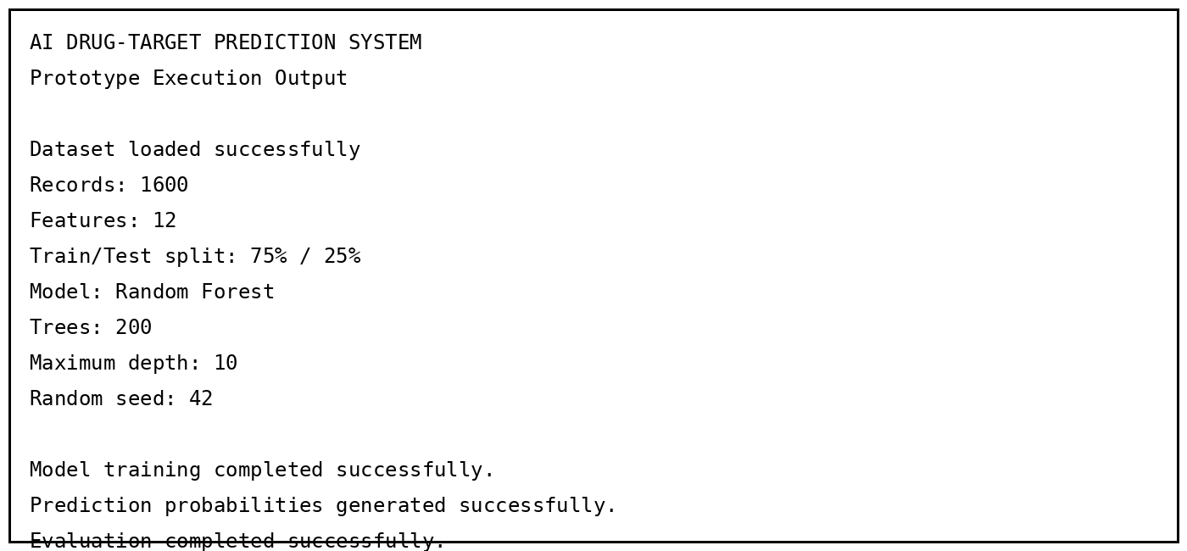
AI DRUG-TARGET PREDICTION SYSTEM
Prototype Execution Output
Dataset loaded successfully
Records: 1600
Features: 12
Train/Test split: 75% / 25%
Model: Random Forest
Trees: 200
Maximum depth: 10
Random seed: 42
Model training completed successfully.
Prediction probabilities generated successfully.
Evaluation completed successfully.
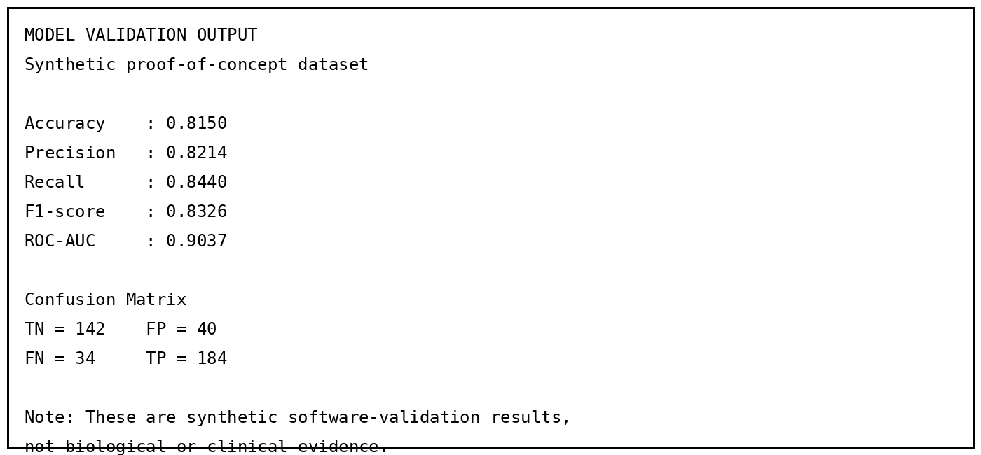
MODEL VALIDATION OUTPUT
Synthetic proof-of-concept dataset
Accuracy : 0.8150
Precision : 0.8214
Recall : 0.8440
F1-score : 0.8326
ROC-AUC : 0.9037
Confusion Matrix
TN = 142 FP = 40
FN = 34 TP = 184
Note: These are synthetic software-validation results,
not biological or clinical evidence.
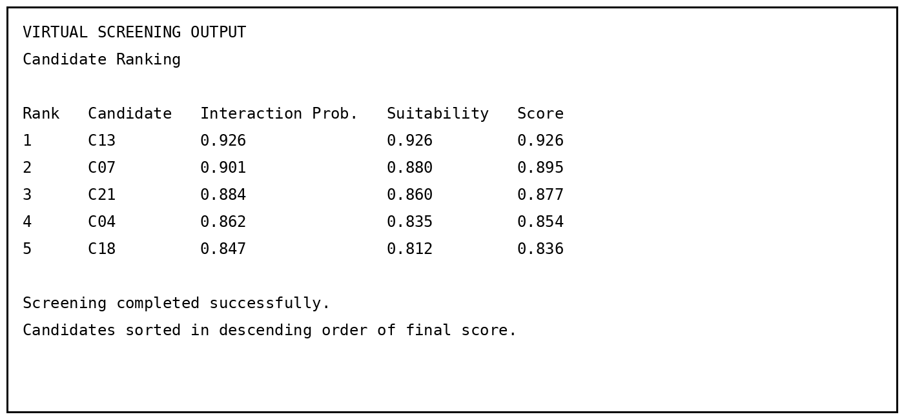
VIRTUAL SCREENING OUTPUT
Candidate Ranking
Rank Candidate Interaction Prob. Suitability Score
1 C13 0.926 0.926 0.926
2 C07 0.901 0.880 0.895
3 C21 0.884 0.860 0.877
4 C04 0.862 0.835 0.854
5 C18 0.847 0.812 0.836
Screening completed successfully.
Candidates sorted in descending order of final score.
Execution Observation
Execution Stage | Observed Output | Status
Data ingestion | 1,600 synthetic records loaded and validated | Successful
Model training | Random Forest trained with specified parameters | Successful
Validation | Accuracy, precision, recall, F1 and ROC-AUC generated | Successful
Candidate screening | Candidates ranked using final screening score | Successful
Reproducibility | Fixed random seed and documented configuration | Successful

ONE-PAGE INDIVIDUAL REFLECTION-M.Naga Shalini(192524183)
Working on the Development of an AI-Based Drug Target Prediction and Drug Screening System helped me understand how artificial intelligence can be connected to a scientific problem through a complete engineering workflow. My main design decision was to begin with a Random Forest classifier instead of immediately using a complex deep-learning architecture. This choice made the prototype easier to implement, test and explain while still allowing nonlinear relationships between the selected drug and target features to be learned. I also separated the interaction-prediction stage from the screening stage so that a prediction probability and a final candidate-ranking score could be inspected independently.
One of the main challenges was understanding that the quality of an AI prediction depends on the data representation and evaluation procedure, not only on the selected algorithm. Cleaning records, handling missing values, preventing data leakage and maintaining a reproducible train/test split were important parts of the development process. Another challenge was deciding how a prediction should be converted into a screening result. I used a simple weighted score for the prototype because it is transparent and easy to audit. I learned that such a score is only a prioritization mechanism and cannot replace laboratory experiments, binding studies, toxicity evaluation or clinical validation.
The assignment improved my knowledge of machine-learning classification, feature engineering, model evaluation and virtual screening concepts. I learned how accuracy, precision, recall, F1-score and ROC-AUC describe different aspects of model behavior. The confusion matrix also helped me understand the practical meaning of false positives and false negatives. The project strengthened my Python skills through the use of data-processing and machine-learning libraries and showed me the importance of documenting model parameters, random seeds and data-processing decisions so that results can be reproduced.
Overall, the assignment contributed to attaining the mapped course outcomes by requiring me to apply technical concepts, design a computational solution, implement and test it, analyze performance, justify engineering trade-offs and communicate limitations clearly.

ASSIGNMENT SUBMISSION REQUIREMENT CHECKLIST
Required Component | Included in Report
Problem Statement and Problem Formulation | Yes – Questions 1 to 5
Objective and Expected Outcomes | Yes
Requirements, Constraints and Assumptions | Yes
Relevant Course Knowledge / Concepts | Yes
Design / Proposed Solution / Methodology | Yes
Algorithm / Pseudocode / Flowchart | Yes
Implementation / Source Code / Environment / Tools | Yes
Test Cases and Expected/Actual Results | Yes
Execution Screenshots / Outputs | Yes – dedicated section
Results and Validation | Yes – metrics, confusion matrix and candidate ranking
Analysis, Comparison, Trade-offs and Justification | Yes
Broader Considerations / SDG Relevance | Yes
Conclusion, Limitations and Possible Improvements | Yes
Individual Contribution of Group Members | Yes
References, Datasets, Software/Tools and Other Sources | Yes
One-Page Individual Reflection | Yes – dedicated one-page section

